TASK 3 – SCRIPTING TASK
- Create a shell script to print the HTTP error code of guvi.in & print, the success/failure message based on the error code response
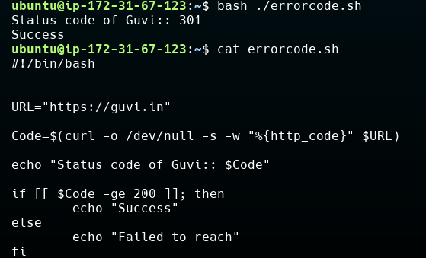
- Given a file, replace all occurrence of the word "give" with "learning" from 5th line till the end in only those lines that contain the word "welcome"
Using sed to replace the word
Starting from 5 to end – 5, $
S and g represent “Substitute” and “global” as part of command syntax
